

An introduction to
China’s National Strategy for Plant Conservation

Sponsors:
State Forestry Administration (SFA)
Chinese Academy of Sciences (CAS)
State Environmental Protection Administration (SEPA)

Drafters:
The Institute of Wild Plant Conservation, North East Forestry University
Botanical Garden Working Committee, CAS
Beijing Botanical Garden, CAS
Wuhan Botanical Garden, CAS
South China Botanical Garden, CAS
Kunming Botanical Garden, CAS
Xishuangbanna Tropical Botanical Garden, CAS

Introduction


One of the world’s top three most biodiverse countries, China boasts an astonishing 30,000 native plant species, making it home to 10% of all known plant species.

Its huge range of climatic zones, spanning from tropical rainforest to frozen tundra, has created a staggering range of species, 50% of which are found nowhere else on earth. Amongst these are some of the world’s most important crop and ornamental species such as tea, rice, soya beans, magnolias, camellias and peaches, along with an estimated catalogue of 5,000 medicinally important plants.

The country also boasts some of the last remaining habitats of ‘relic’ plant species, such as the majestic gingko and dawn redwood, which although predating the dinosaurs are now confined to only a few scattered patches of mountainous forest.
The Mount Heng Duan region, home to 225 rhododendron species, is one of China’s richest forest ecosystems.

Yet despite this great richness, China’s flora is coming under increasing threat from its explosive economic growth. In its head-long race towards industrialisation, mammoth development schemes, intensive agricultural projects and the over harvesting of timber and medicinal plants have taken an alarming toll on wild plant communities. The cumulative effect of these factors has been an unnerving ten fold leap in the number of threatened plant species since 1992, with up to 20% of China’s native plants now considered at risk.

Despite good progress in several areas, such as the establishment of nature reserves, which have increased in number from just 45 in the late 1970’s to over 2,300 today (a 52 fold increase), this is the first time a coordinated, nation-wide plan has been developed to address China’s spiralling loss of plant diversity.

The timely launch of China’s national strategy aims to tackle the plant conservation issue head-on, demonstrating its firm commitment to the environment, as well as its international obligations as a signatory to the Convention on Biological Diversity (CBD). Indeed China is one of the first of the 187 signatory countries to the CBD to fulfil its commitment by publishing a national strategy following the agreed targets of the Global Strategy for Plant Conservation. This document sets out specific and measurable conservation targets that can be used as a yard stick for measuring the success of both existing and future conservation efforts.

Coming in the face of the looming ecological crisis, the catalyst to the creation of this strategy was a meeting of Chinese state officials initiated and organised by Botanic Gardens Conservation International (BGCI) in Beijing in November 2006, with funding from the UK Department for Environment, Food and Rural Affairs (Defra).

Coordinated by the Chinese Academy of Sciences (CAS), the State Environmental Protection Administration (SEPA) and the State Forestry Administration (SFA) in combination with other related departments, the far reaching strategy covers 16 targets focusing on 4 key plant diversity themes. These themes span 1) Understanding and documenting existing plant diversity, 2) Conservation of plant diversity, 3) Sustainable use of wild plant resources, and finally 4) Generating public awareness and education of plant diversity. It is according to these four themes that this summary document is laid out.

Theme 1. Understanding and documenting existing plant diversity

In order to efficiently conserve a nation’s flora, it is vital to gain a thorough understanding of the current state of wild populations, present botanical collections and conservation efforts.

Current status

- China’s vast flora has been documented in the ‘Flora Republicae Popularis Sinica’, whose 31,142 species entries span 80 volumes and 126 published books, as well as the 12-volume ‘Flora of China’, available in English. Additionally, most of China’s provinces and municipalities have also published their local flora, such as the 21-volume ‘Flora of Yunnan’.

- A ‘virtual herbarium’, an innovative online resource containing scanned images of pressed plants and associated information, is under development.

- The first Red Data Book, a catalogue that lists rare species and those in danger of extinction, for China’s plants was published in 1992. Later in 1999 this was complemented by the publishing of China’s ‘Catalogue of Wild Plants Under Special State Control’.

- A number of models for the conservation and sustainable use of plants have been developed, tailored specifically to the local situation in China.

Actions planned

- Launching a new national survey of plant species and habitats, starting with key areas and groups of plants. This will include ensuring that recently discovered species are added to the flora and old records are verified. Significantly this will incorporate a conservation assessment, focusing initially on known threatened plants, plants of economic importance and endemic species.

- Accelerating the construction of China’s National Herbarium as well as the development of a national network of herbaria.


- Completing the development of the virtual herbarium and making digitised specimens available via the internet.

- Conducting a survey of the population status of plants both in situ (in their native habitat) and ex situ (in managed collections, such as botanic gardens) conservation programmes.

- Completing the updating of the Plant Red List (a list of native threatened and endangered plants species) by 2012.
Fields of cultivated ‘wild’ barley, found only in the Chinese Himalayas, demonstrate the importance of local and ethnic crop varieties.

- Developing and scaling-up models for the further conservation and sustainable use of plants in China.

Theme 2. Conservation of plant diversity

The strategy details a comprehensive plan for conserving native plants, both in situ (in their native habitat) and ex situ (in managed collections). This dual method is considered the most robust approach to wildlife conservation, providing an important ‘back up’ against uncertainty.

Current status

- Since 1956 China has established 2,349 nature reserves, covering 15% of its land area. In addition, the large number of forest parks and small reserves provide a basis for the development of a network of in situ conservation areas for wild plants.

- 65% of China’s higher plant communities, including most plants under national key protection, are currently conserved in these state-controlled nature reserves.

- To date more than 160 botanic gardens and arboreta have been established in China, cultivating 60% of its regionally important plants.

- A national Chinese seed bank (containing 340,000 accessions) and a network of regional seed banks ensures the long-term conservation of the genes of important crops, such as rice and soya beans.

- A national medicinal plant genetic resource bank is currently being established.

Actions planned

- Reviewing China’s current network of nature reserves to ensure that all of its major ecological zones are represented – with particular emphasis on desert, grassland and wetland ecosystems.

- Launching assessments into the impact of proposed development projects on plant diversity.

- Banning development projects in areas where pollution is deemed to be likely to impact on key biodiversity areas.

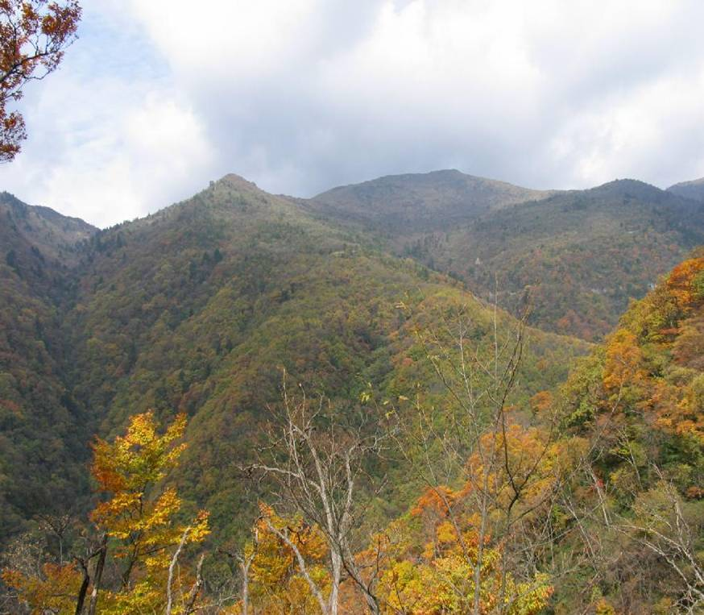
- Establishing a wild plant monitoring system, whose remit will include protecting 90% of key conserved wild plants by 2010.

- Establishing a national network of ex situ conservation centres, based in China’s 160 botanic gardens.

- Ensuring the conservation of 70% of the genetic diversity of China’s major economic plants.
Known as China’s ‘Green Gene Pool’,
Sheng Nong Jia Reserve is home to the wild relatives of many major crops, as well as the last remaining wild ginkgos.

Theme 3. Sustainable use of wild plant resources

Ensuring the sustainable use of wild plant resources is of key importance to conservation as unsustainable collection is often a key driver in the extinction of economically valuable species.

Current status

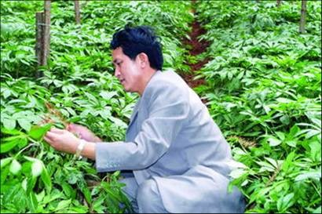
- China is a signatory to CITES (Convention on International Trade in Endangered Species of Wild Flora and Fauna) and has enacted laws to prevent the illegal trade in endangered plants. Inspection stations have been established at major ports such as Shenzen and Dalian to enforce these laws.
Centuries of over harvesting have driven wild ginseng to the brink of extinction. Artificial cultivation schemes are helping take pressure of wild populations.

- Over 11,000 species are used in traditional Chinese medicine. Of the 600 plant species that are regularly used, sustainable cultivation systems have been developed for 200 species, thereby preventing their unsustainable harvesting from the wild.

- China’s first organic and ‘green’ product certification schemes have been introduced and are being actively promoted. This currently includes over 12,868 Chinese products which have been certified as ‘green’.

- Forest certification schemes, which officially verify the ‘green’ credentials of sustainably sourced timber, are under development.

- Several volumes of the China ethno-medicine encyclopaedia have been published, which officially catalogues the uses and preparation methods of a wide range of medicinal plants.

Actions planned

- Active state promotion of a wide range of sustainable agricultural practices, including organic growing.

- Building ecological criteria into new development projects, including the construction of 10,000 new ‘eco-villages’.

- Commissioning a study into the scale of the international trade in wild Chinese plants.

- Initiating an aggressive crack down on illegal logging and over-exploitation of medicinal plants and timber.

- Strengthening support for the nascent development of forest certification schemes.

- Actively promoting the cultivation of useful wild plant species, to relieve the pressure of harvesting on wild plant populations, including close monitoring of the populations of plant resources in the wild.

- Systematically collecting and documenting traditional knowledge, particularly that of minority ethnic groups, as part of a broader effort to preserve traditional cultures.

Theme 4. Generating public awareness and education of plant diversity

Support at grass roots level is vital to the success of any major conservation project. Generating public awareness for plant conservation is particularly important in the Chinese context, where popular knowledge and support for environmental issues remain low.

Current status

- Plant diversity conservation, as part of broader environmental education, has been incorporated into the Chinese primary and secondary school curricula.

- China runs a number of large-scale public environmental awareness campaigns each year. Tied to specific themes such as ‘Tree Planting Day’, ‘Earth Day’, ‘National Laws and Regulations Publicity Day’, these campaigns typically include the hosting of news conferences, international conventions and painting exhibitions.

- Forest parks, botanic gardens and nature reserves are overwhelmingly popular attractions in China, and play a significant role in plant diversity conservation and education. In 2005 these facilities together attracted over 440 million visitors.

Actions planned

- Equipping every administrative level of the Chinese state government with a wild plant conservation campaign branch.

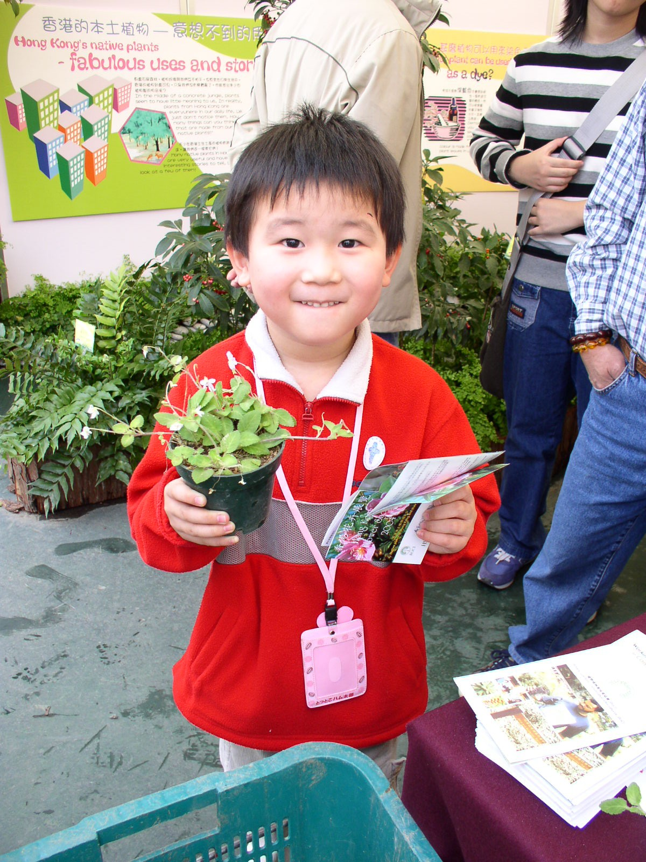
- Establishing a specialised plant diversity campaign team in each regional / local nature conservation institution.

- Designating a national ‘Wild Plant Conservation Day’ as part of the existing calendar of large-scale state public environmental awareness campaigns.

- Investing heavily in improving environmental campaigns and education websites as well as visual and audio databases, in order to modernise education and training approaches.

- Founding ‘green nursery schools’, ‘green schools’ and ‘green universities’, as well as ensuring that environmental courses and lectures are incorporated into non-environmental fields.
From kindergarten to university level, China is launching a massive investment programme into environmental education.
- Opening up China’s botanic gardens to the outside world in order to share scientific knowledge and expertise with partners around the globe.

Summary document prepared by Botanic Gardens Conservation International (BGCI)  www.bgci.org  020 8332 5953  Descanso House, 199 Kew Road, Richmond, Surrey, TW93BW, U.K. | 

