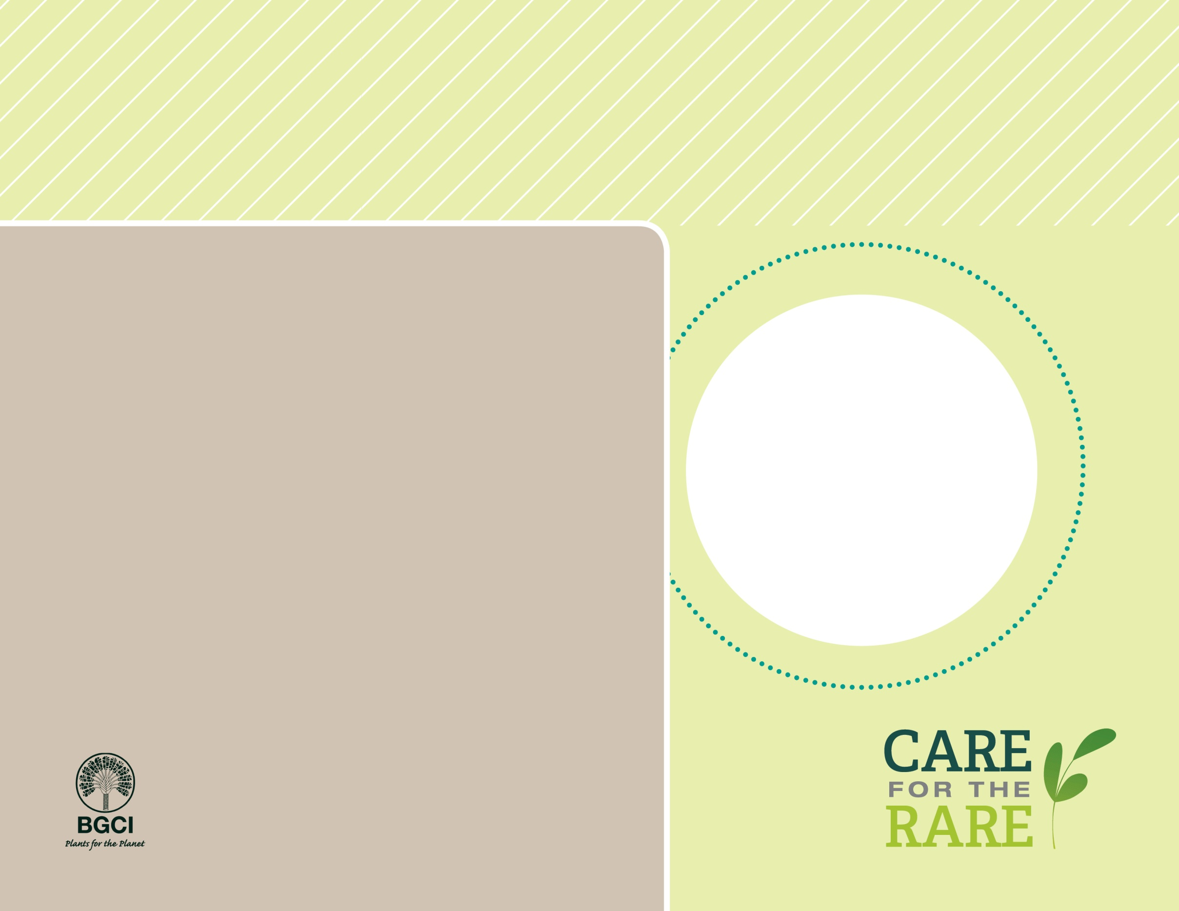

Nevin’s barberry

*Berberis nevinii*

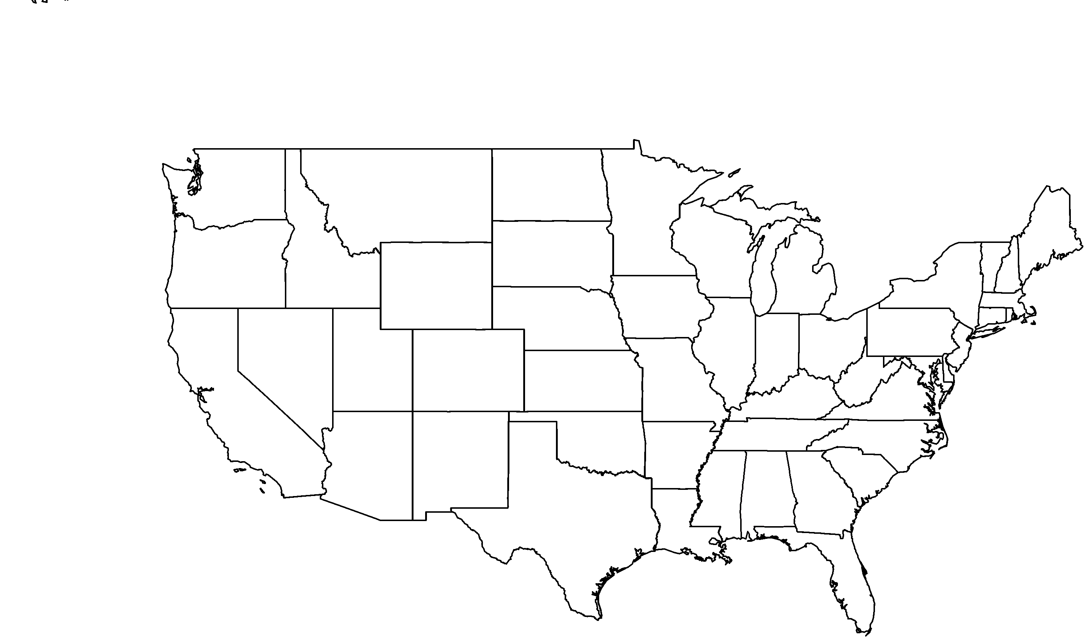

**About me:** I am a SoCal native! I am also on the federal and state list of endangered plants. Some of my kind have been moved from areas slated for development to the safety of botanic gardens.

**Why I’m rare:** I love sandy washes and chaparral-covered slopes, but much of my native habitat in Los Angeles and surrounding area has been lost due to urban development.

**My story:** My beautiful yellow flowers are fragrant and have six petals. My red fruits are edible. Birds transport my seeds from gardens I can be found growing in limited numbers along the urban-wildland interface zones of Southern California.

**How you can help:** I am a plant of critical conservation concern. You can contribute to conservation and restoration efforts at gardens to secure my future.

**PHOTO BY: JAMES GAITHER**

**Your**

**Logo**

**Here**