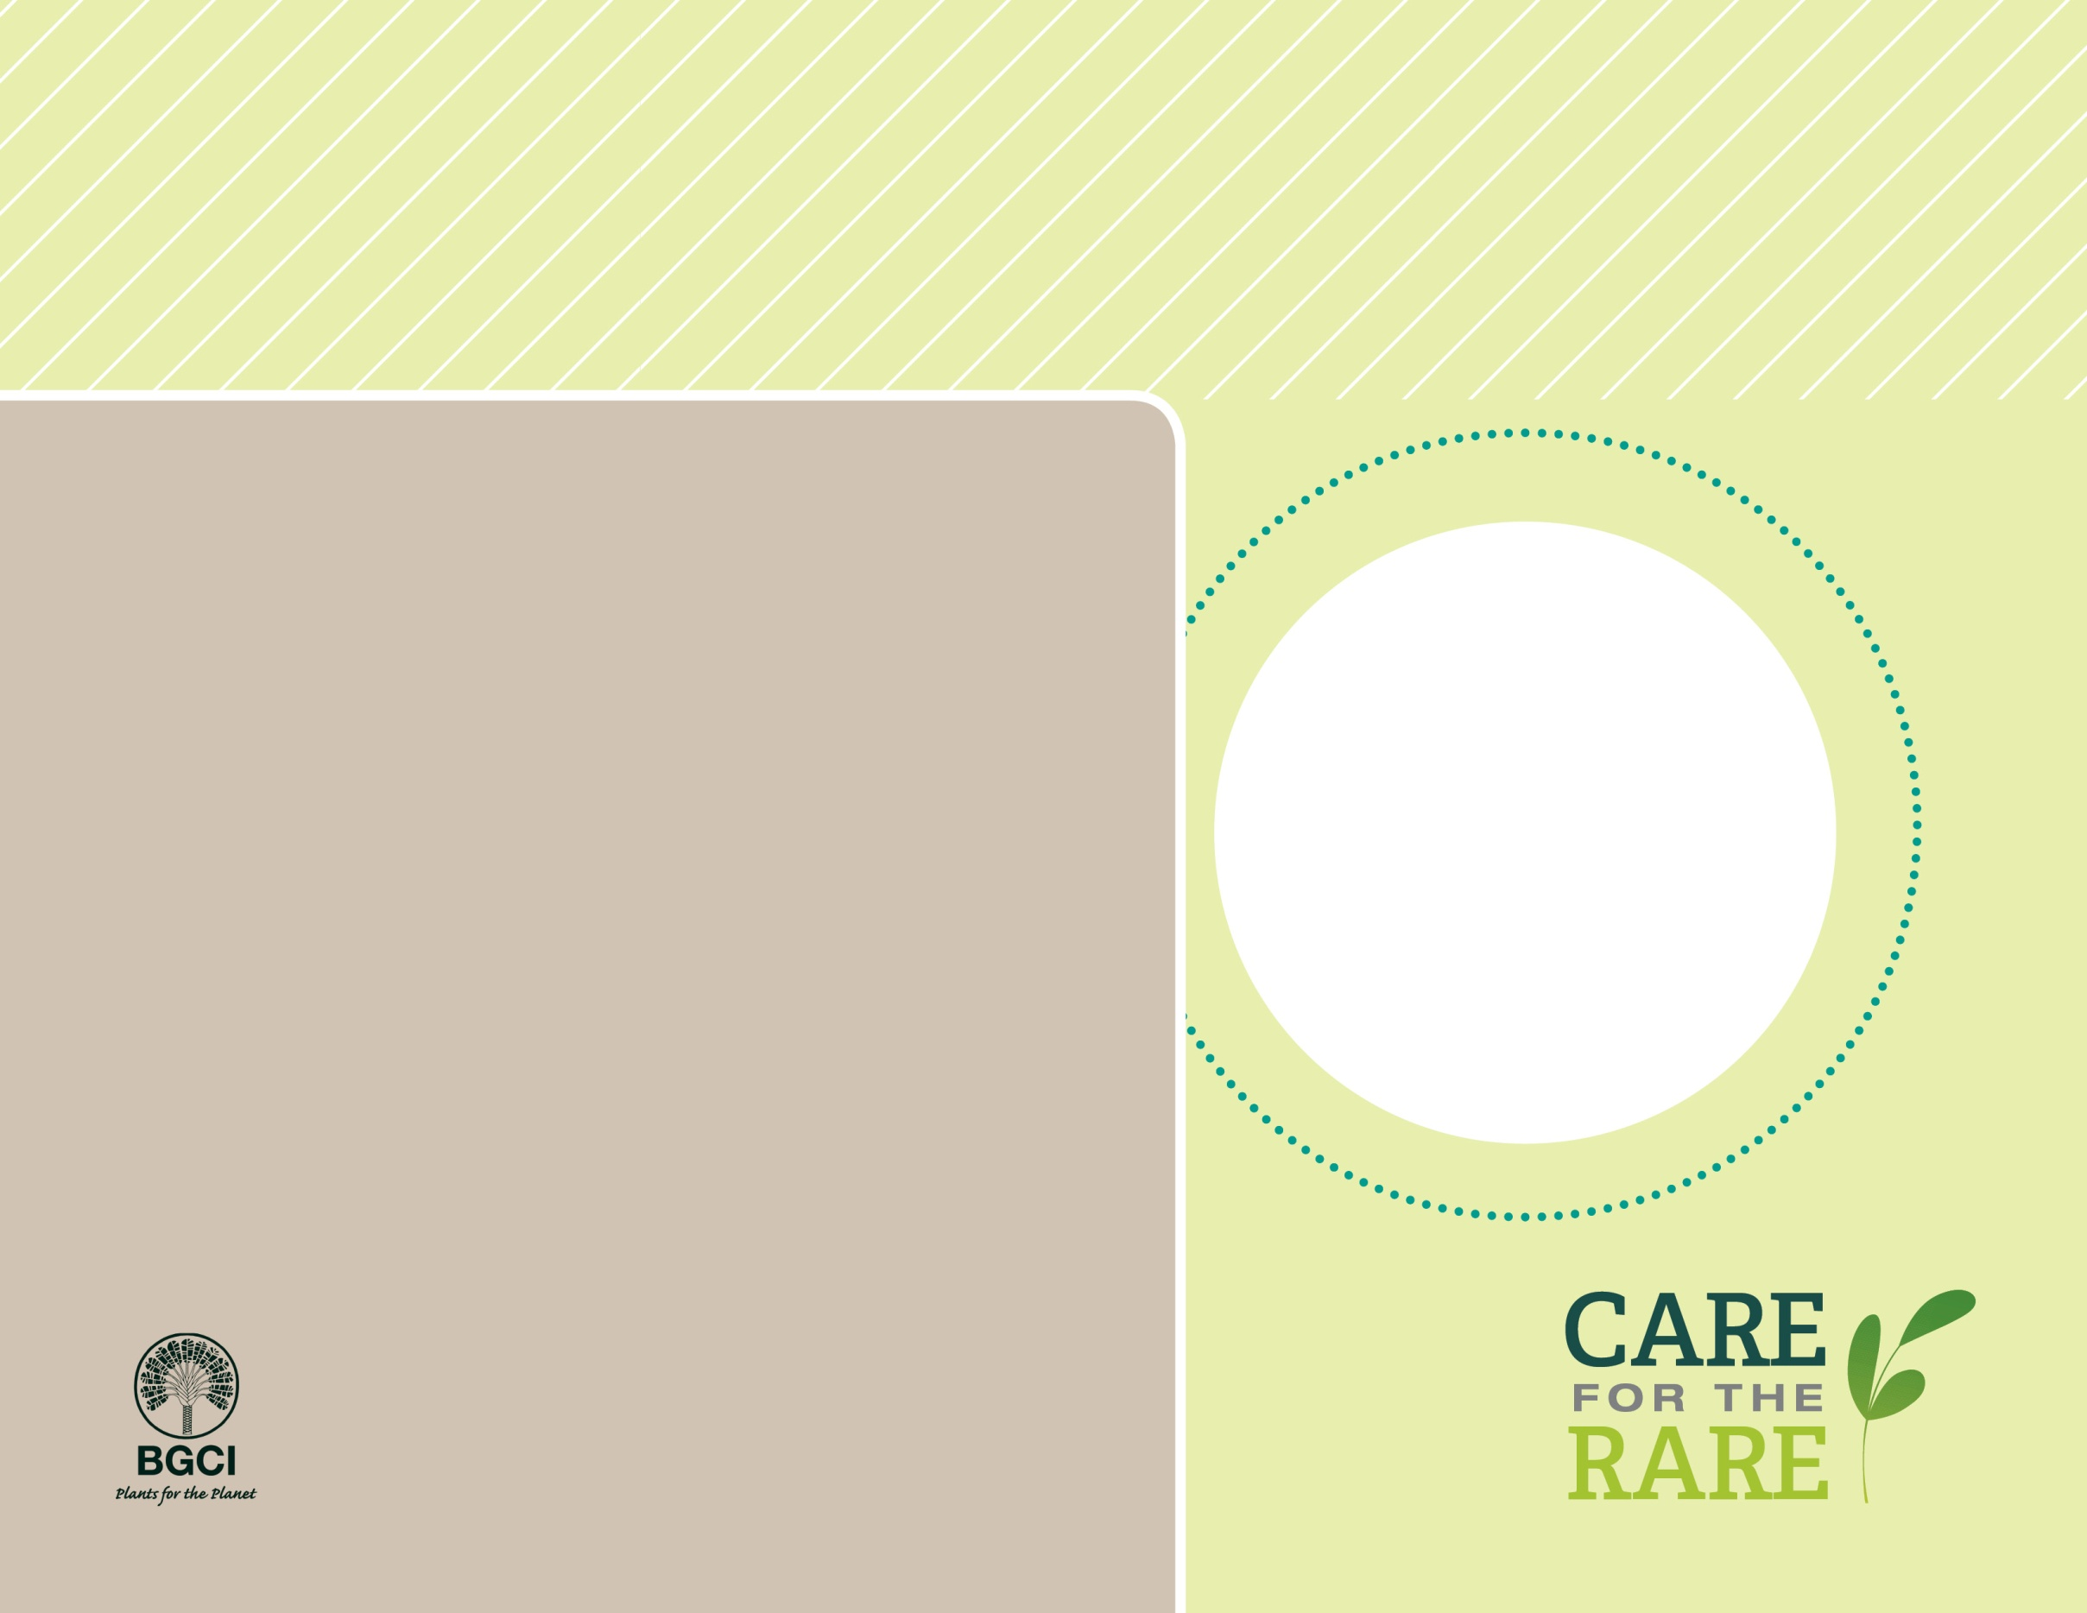

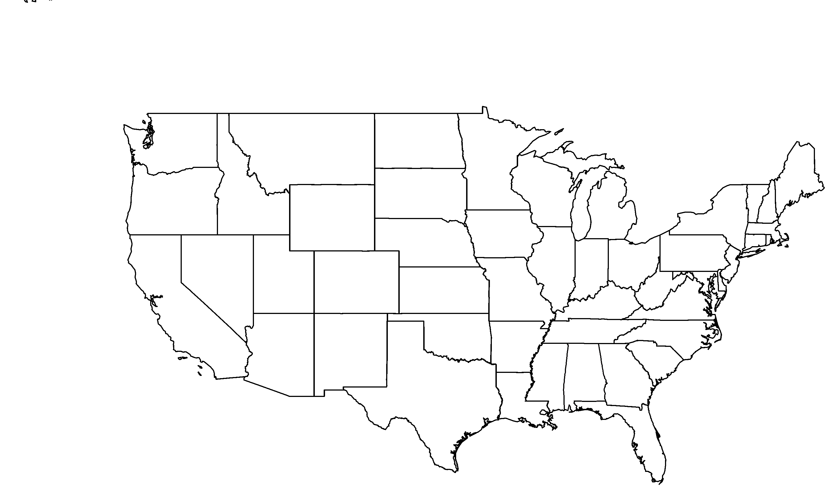

**PHOTO BY: MICHAEL WALL, RANCHO SANTA ANA BOTANIC GARDEN**

**About me:** You can find me on several of the Channel Islands, including Santa Catalina, San Clemente and even Guadalupe (Mexico). I also live on the Palos Verdes peninsula. Did you know Palos Verdes peninsula was once an island?

**Why I’m rare:** On the Palos Verdes peninsula, I thrive in the soil of one small canyon. Introduced animals are a threat because they overgraze me and have caused major environmental changes in most of my island habitats.

**My story:** My numbers declined to single digits on San Clemente and Guadalupe Islands, but don’t you worry; I am currently making a come-back on San Clemente.

**How you can help:** Help support efforts near your neighborhood to conserve your local native flora by donating, becoming a member, or volunteering at a garden near you.

California rockflower*Crossosoma californicum*

**Your**

**Logo**

**Here**