

**PHOTO BY: MICHAEL WALL, RANCHO SANTA ANA BOTANIC GARDEN**

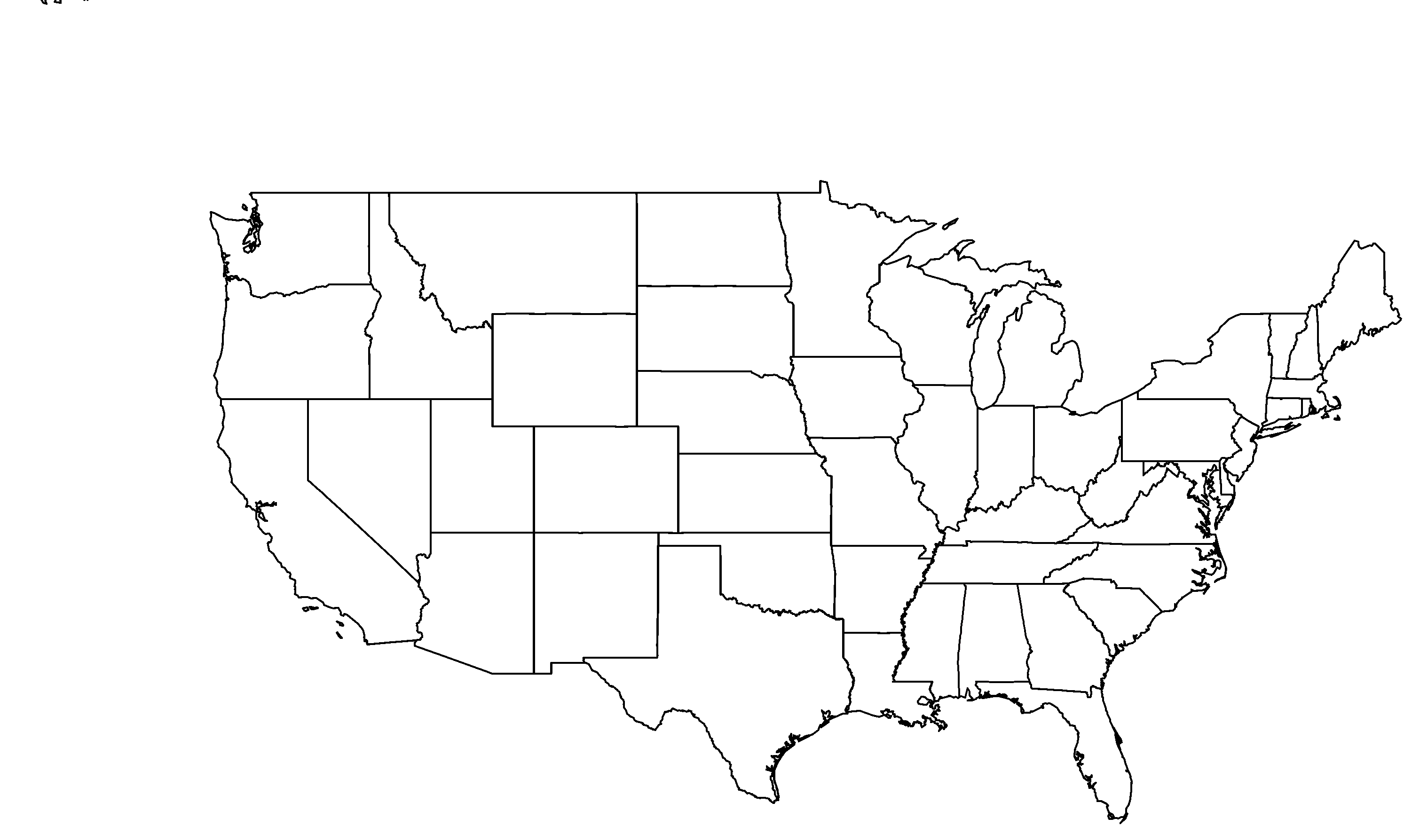

**About me:** My bright yellow flowers and lavish blue-gray foliage are visible all year round. I can only be found on three of the Channel Islands: Santa Catalina, Santa Cruz, and Santa Rosa.

**Why I’m rare:** Grazing by introduced animals has damaged the natural vegetation of my island homes and caused my soil to erode. To make matters worse, these changes have favored other non-native plants that cause further destruction to my home.

**My story:** My seeds respond well to fire and other types of disturbance. Suppression has reduced the frequency of fires so my seeds do not get the stimulus they need to germinate and grow.

**How you can help:** Volunteer to help protect and conserve native habitat near you!

Island bush poppy*Dendromecon harfordii*

**Your**

**Logo**

**Here**