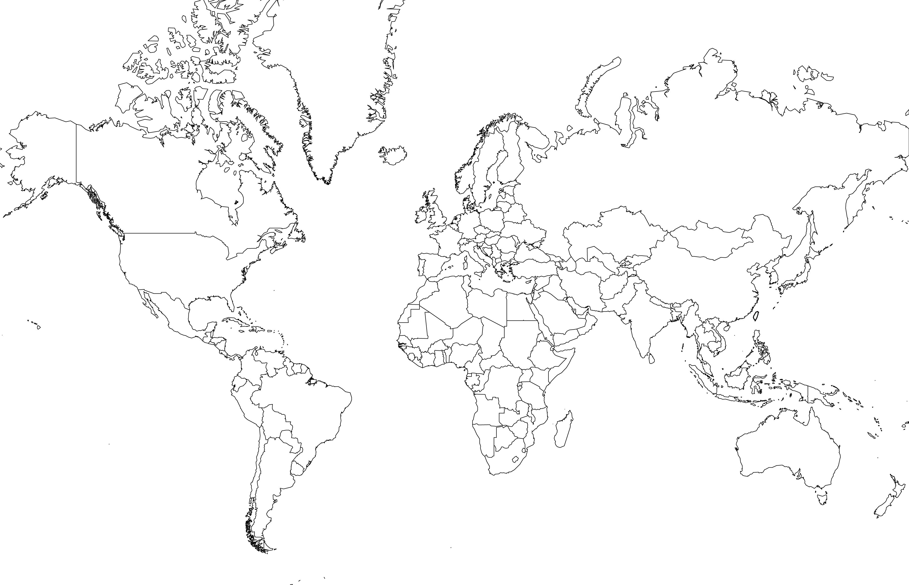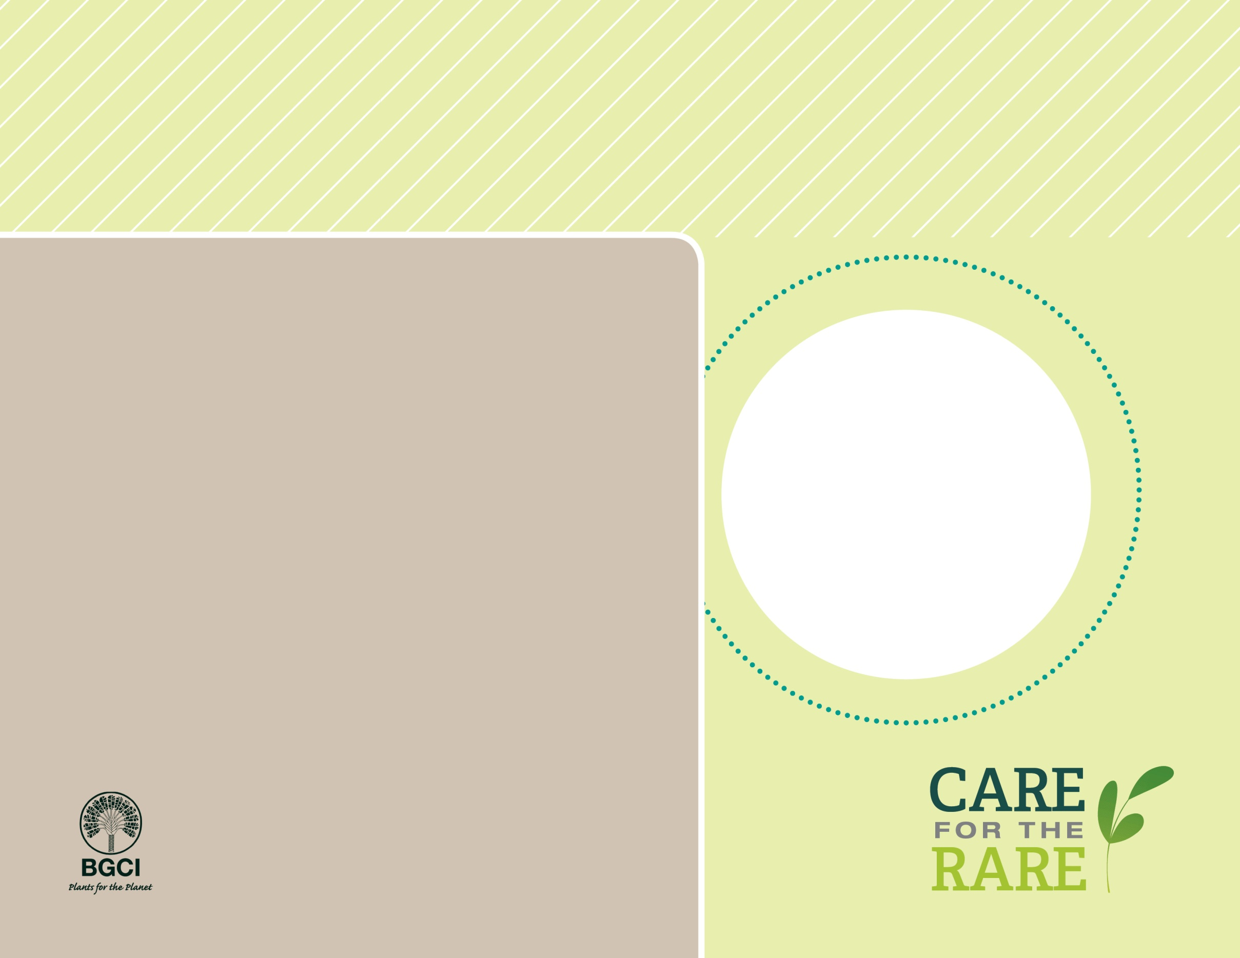

**About me:** I’m a small, umbrella-shaped tree from the Canary Islands, Morocco, Madeira and Cape Verde. I also grow in botanic gardens and homes around the world. People used me as medicine long ago, and my dark red sap has been called “the blood of the dragons” that is used today to stain wood for violins.

**Why I’m rare:** I grow very slowly and only flower every 15 years! My habitat has disappeared because of agriculture and fires. Introduced rabbits, rats, and goats eat my leaves and seeds too. Today only a few individuals remain in places where I was once common.

**My story:** I am now protected from wild-collection by national laws, and people are trying to protect the land where I grow. I grow in many botanic gardens around the world as an extra safety net.

**How you can help:** Don’t “pack a pest” when you travel: fruits, vegetables, other plants and animals can carry (or become) invasive pests when brought to new places.

Canary Islands dragon tree

*Dracaena draco*

PHOTO BY: UNITED STATES BOTANIC GARDEN