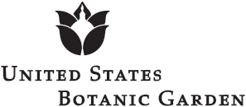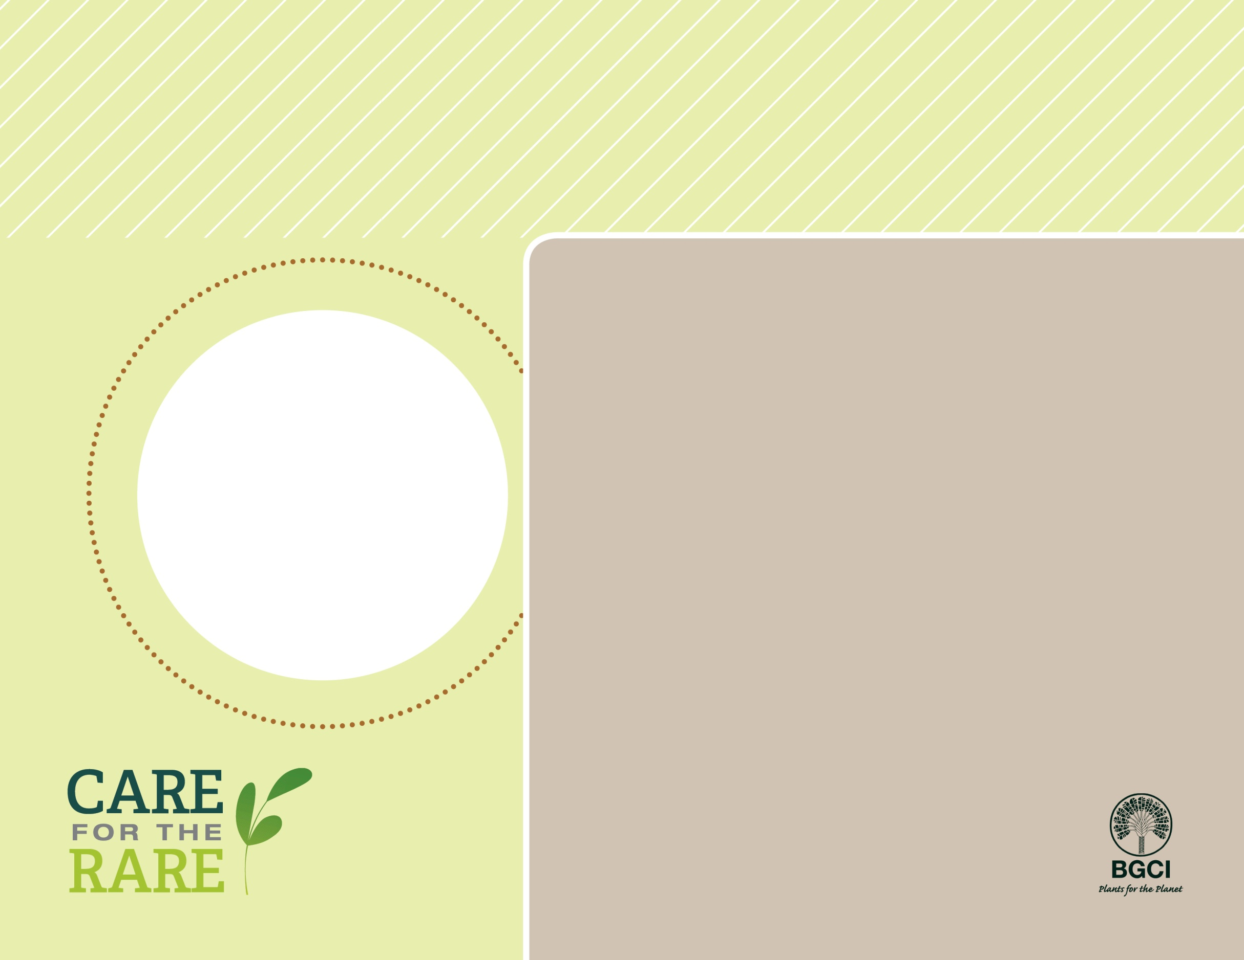

**About me:** I live in the arid shrub lands of South Africa, and my stiff, spiny blue leaves have made me a popular house and garden plant throughout the world.

**Why I’m rare:** I grow very slowly. In the past 50 years, people wanted me in their gardens so I have been illegally harvested from the wild. Recently, urban development has destroyed some of my few remaining populations.

**My story:** Even though my wild populations are declining, I’m safely grown in at least 70 botanic garden collections all over the world. There is now less pressure to collect me from the wild because people have studied how to grow me from seeds.

**How you can help:** Volunteer to help protect and conserve natural areas where you live, and don’t collect plants from the wild.



PHOTO BY: UNITED STATES BOTANIC GARDEN

Eastern Cape blue cycad(*Encephalartos horridus*)