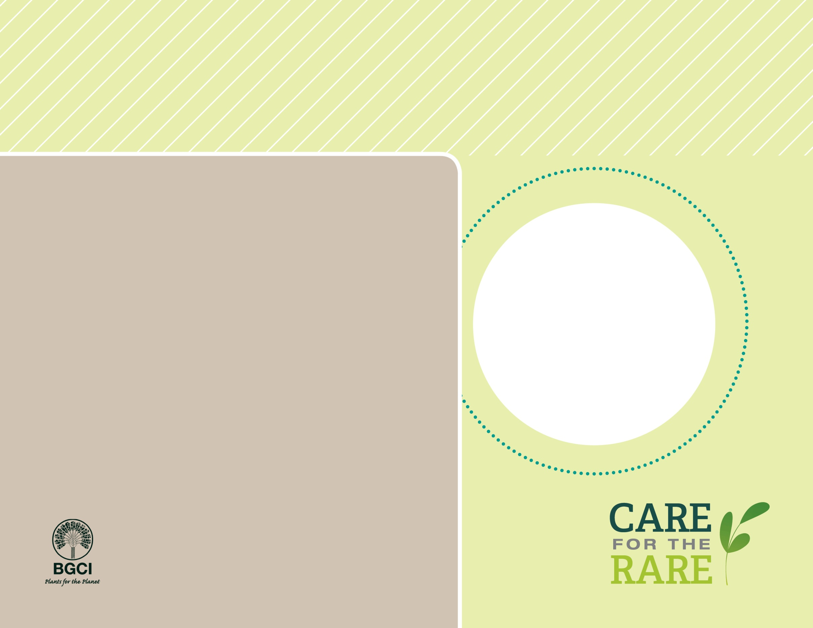

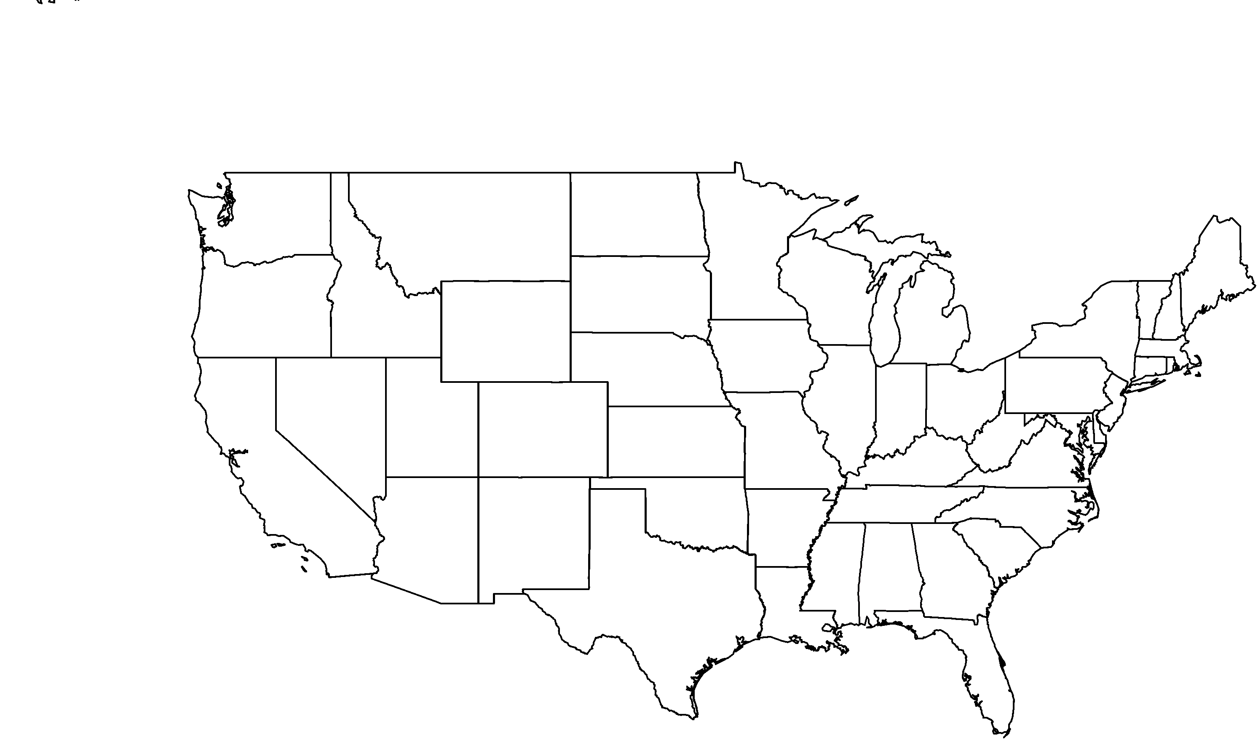

**About me:** In the wild, I grow on three of California’s Channel Islands exclusively. My beautiful clusters of small white flowers bloom in the spring and early summer.

**Why I’m rare:** Until six million years ago, I grew throughout much of the western United States. It is likely that natural climate shifts through the past few centuries have reduced my home range dramatically. I may be vulnerable to future climate change: even my island homes may not be safe.

**My story:** I am a tree with extremely dense and hard wood; this feature has earned me the common name of ironwood.

**How you can help:** Volunteer to help protect and conserve natural areas. Many botanic gardens have active conservation volunteer programs.

**PHOTO BY: RANCHO SANTA ANA BOTANIC GARDEN**

Santa Cruz Island ironwood*Lyonothamnus floribundus* subsp. *asplenifolius*

**Your**

**Logo**

**Here**