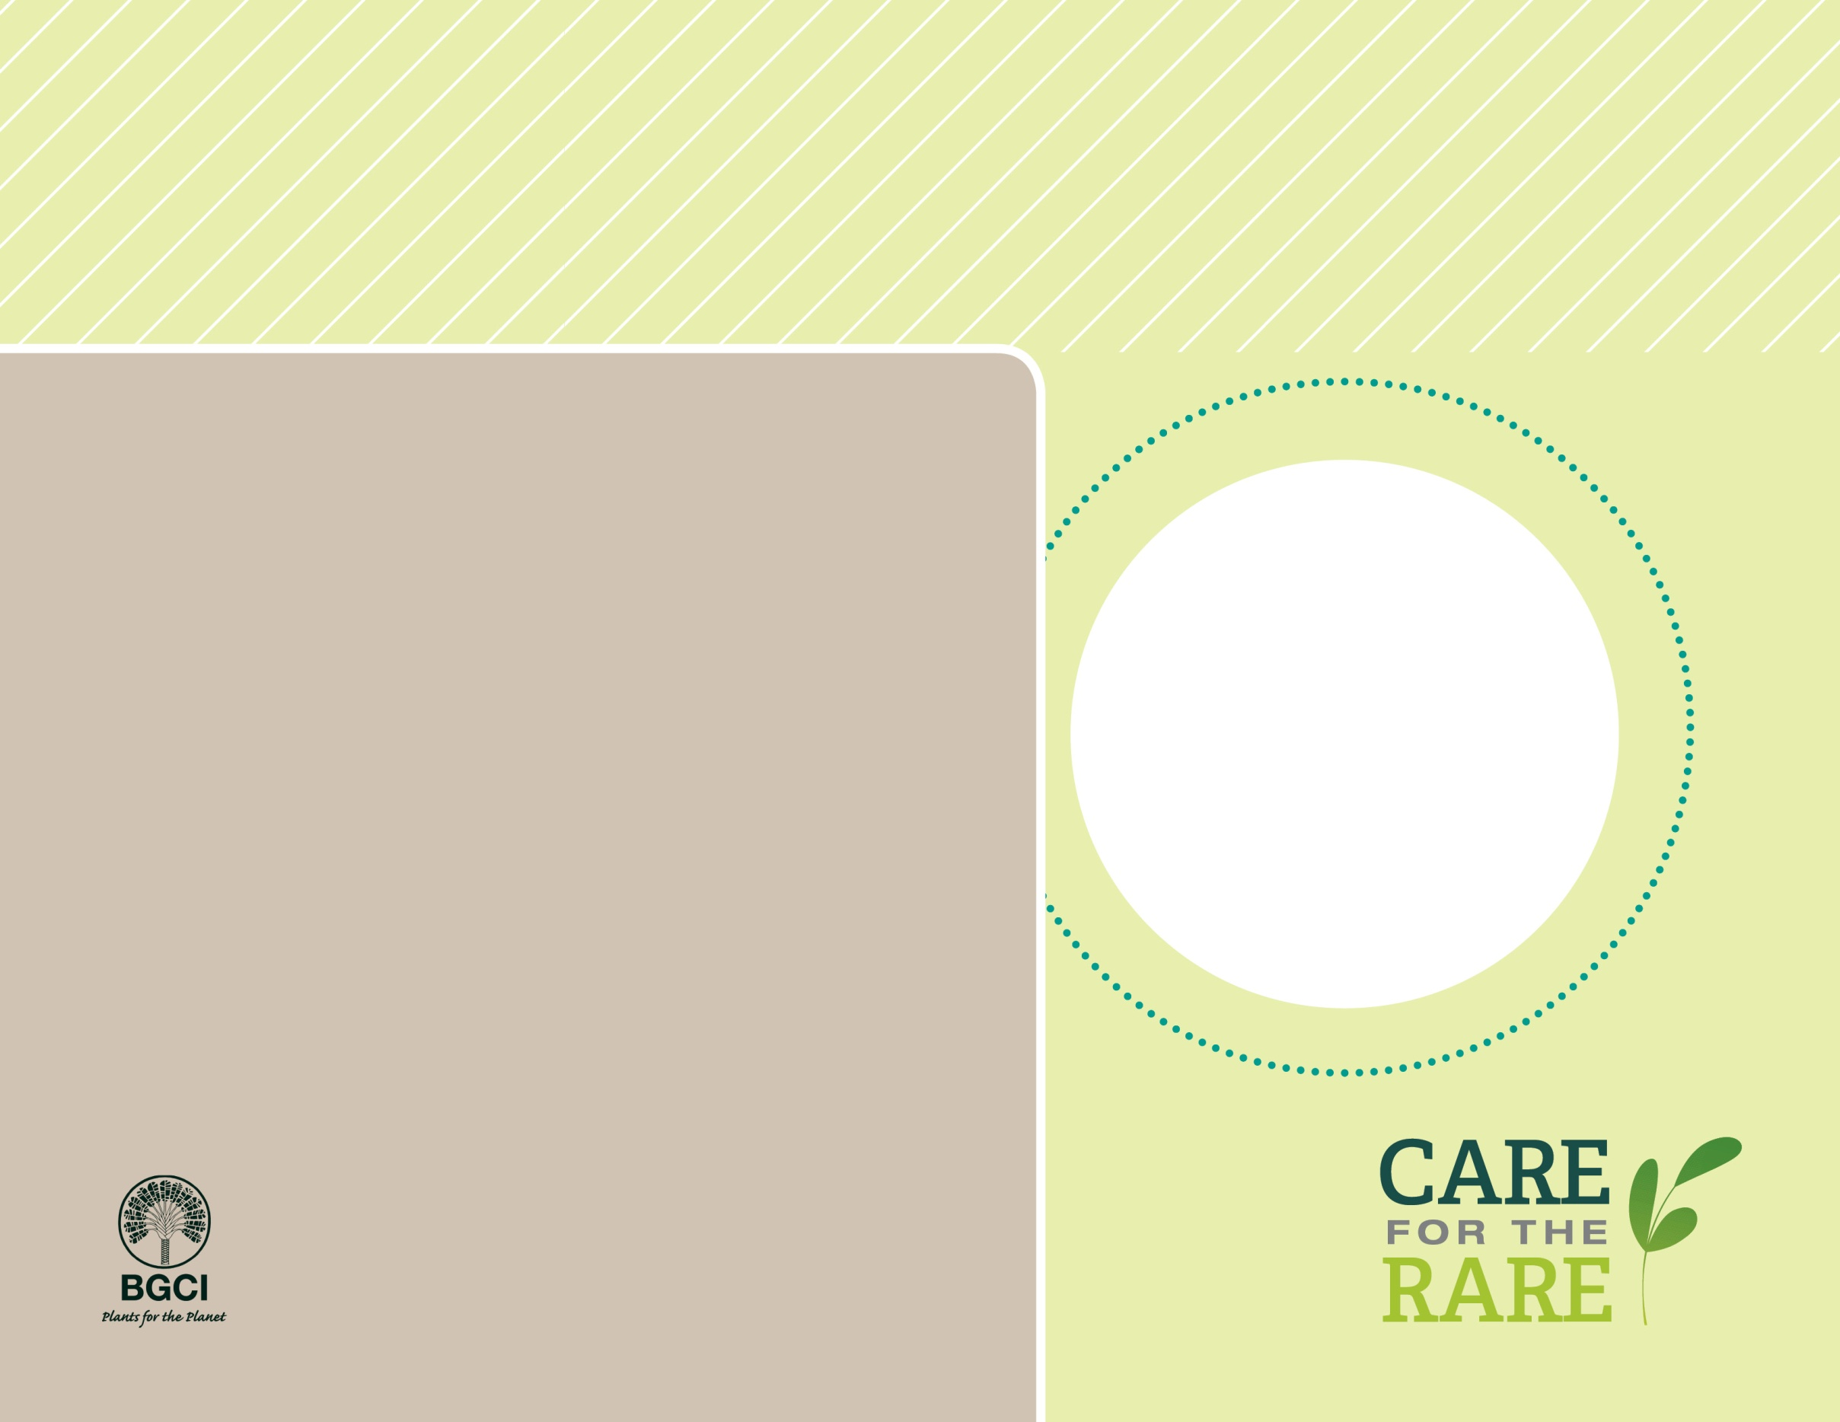

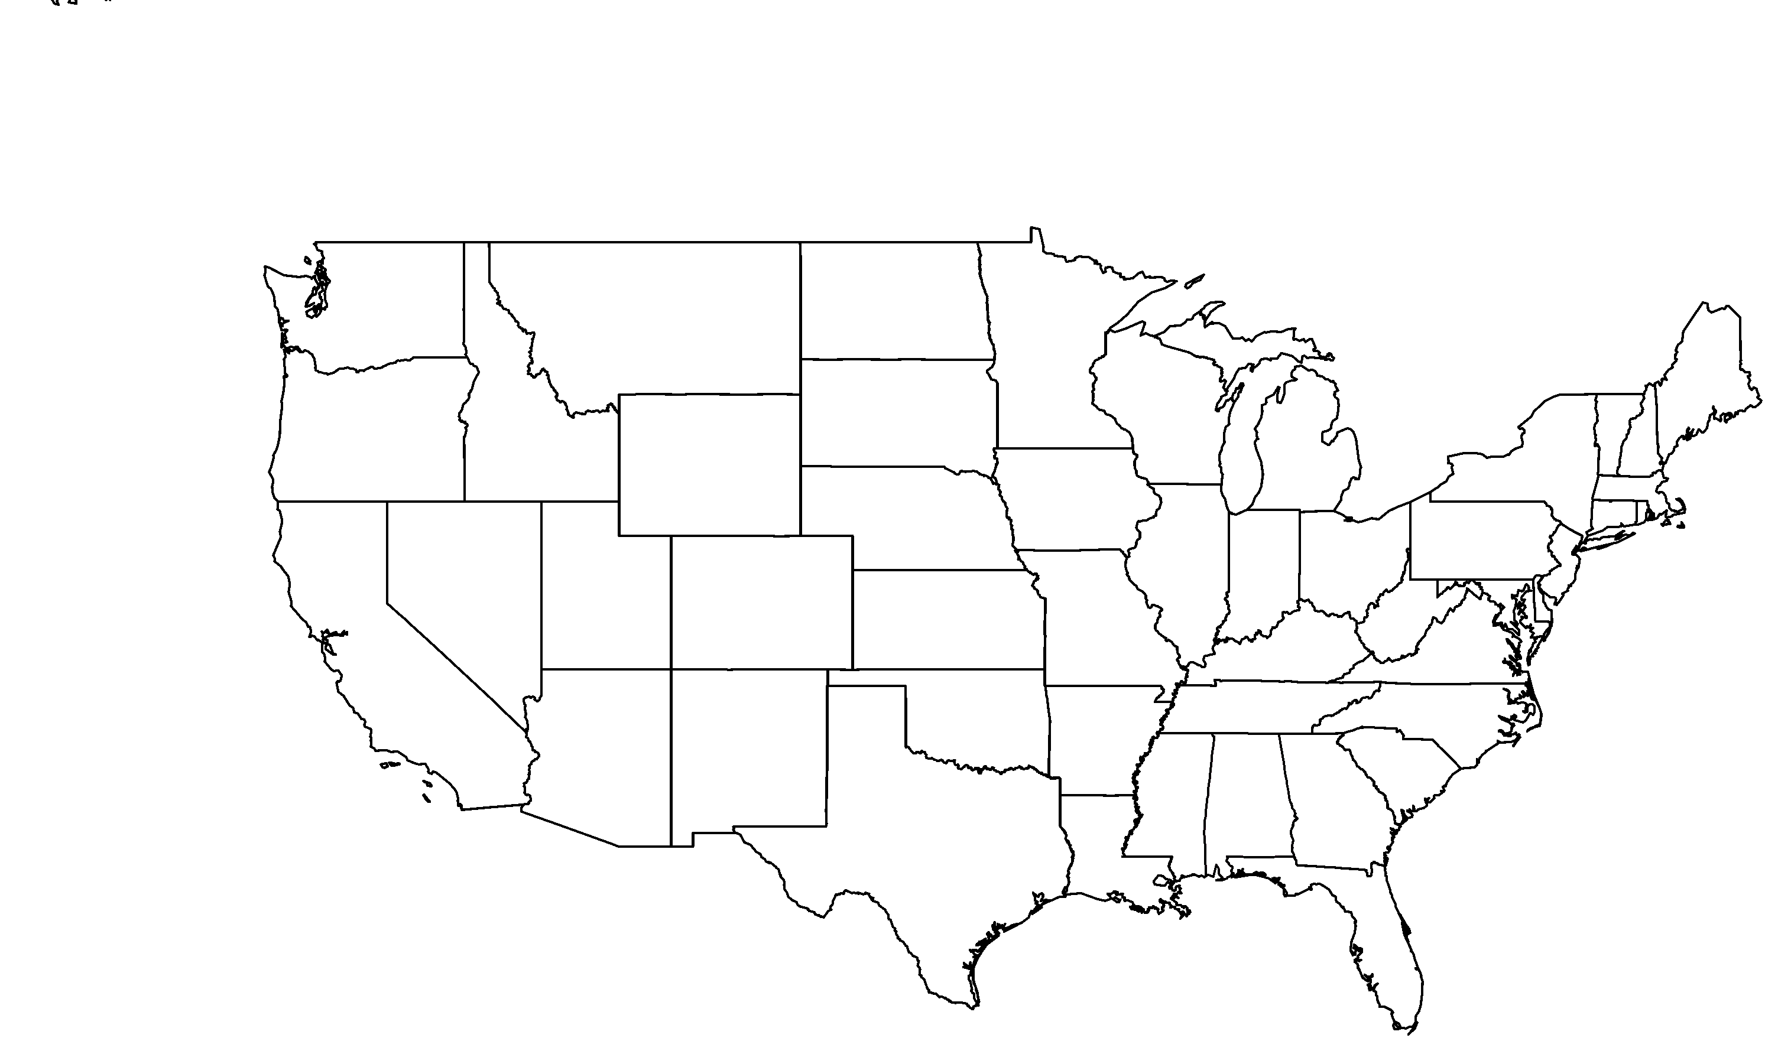

**About me:** I’m the rarest magnolia in North America, and make my only home in the hardwood forests of the Florida panhandle. .

**Why I’m rare:** I’ve had trouble adjusting to logging, invasive plant species, trampling and even trash dumping that is happening in my habitat.

**My story:** Many people are helping to protect the habitat where I grow, and you can find me in more than 50 botanic gardens around the world. Some gardens are studying how to grow me and bank my seeds as a long-term insurance policy against extinction.

**How you can help:** Volunteer to help protect and conserve natural areas where you live.

PHOTO BY: STEFAN BLOODWORTH, DUKE GARDENS

Ashe magnolia(*Magnolia ashei*)