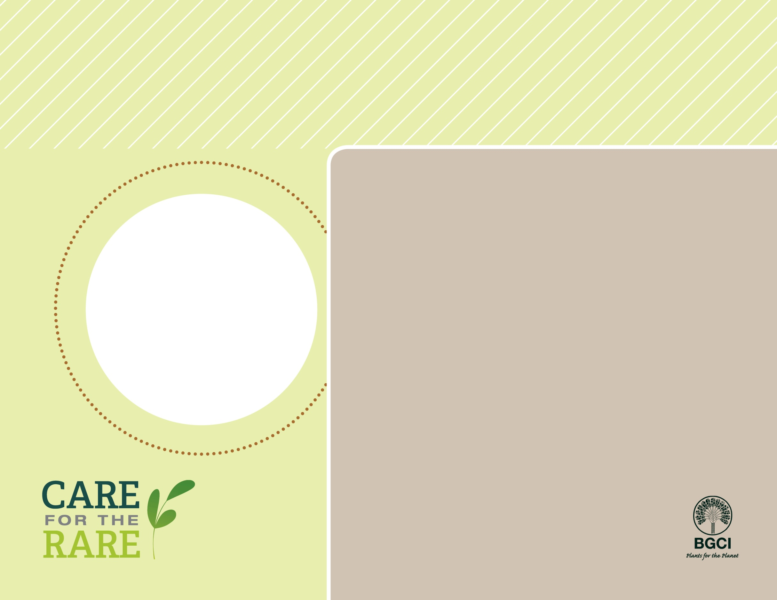

**About me:** I am known as the old woman cactus because of the grayish hairs that protect me from the harsh sun in my habitat in Mexico’s Chihuahuan Desert.

**Why I’m rare:** Like many cactus species, I grow very slowly and have a difficult time finding a safe place to live in the wild. My habitat is easily damaged by human development and also the grazing of animals. To make matters worse, I’m often illegally harvested and sold to plant collectors.

**My story:** Mexico is home to more than 500 cactus species – that’s more than any country in the world! Just in the Chihuahuan Desert, you can find at least 200 cactus species like me: more than ½ of us are endangered.

**How you can help:** I am a popular houseplant, but before you buy me please make sure that I’ve been nursery propagated, and not collected from the wild.

PHOTO BY: ROLF THUM



Old Woman Cactus

(*Mammillaria hahniana*)