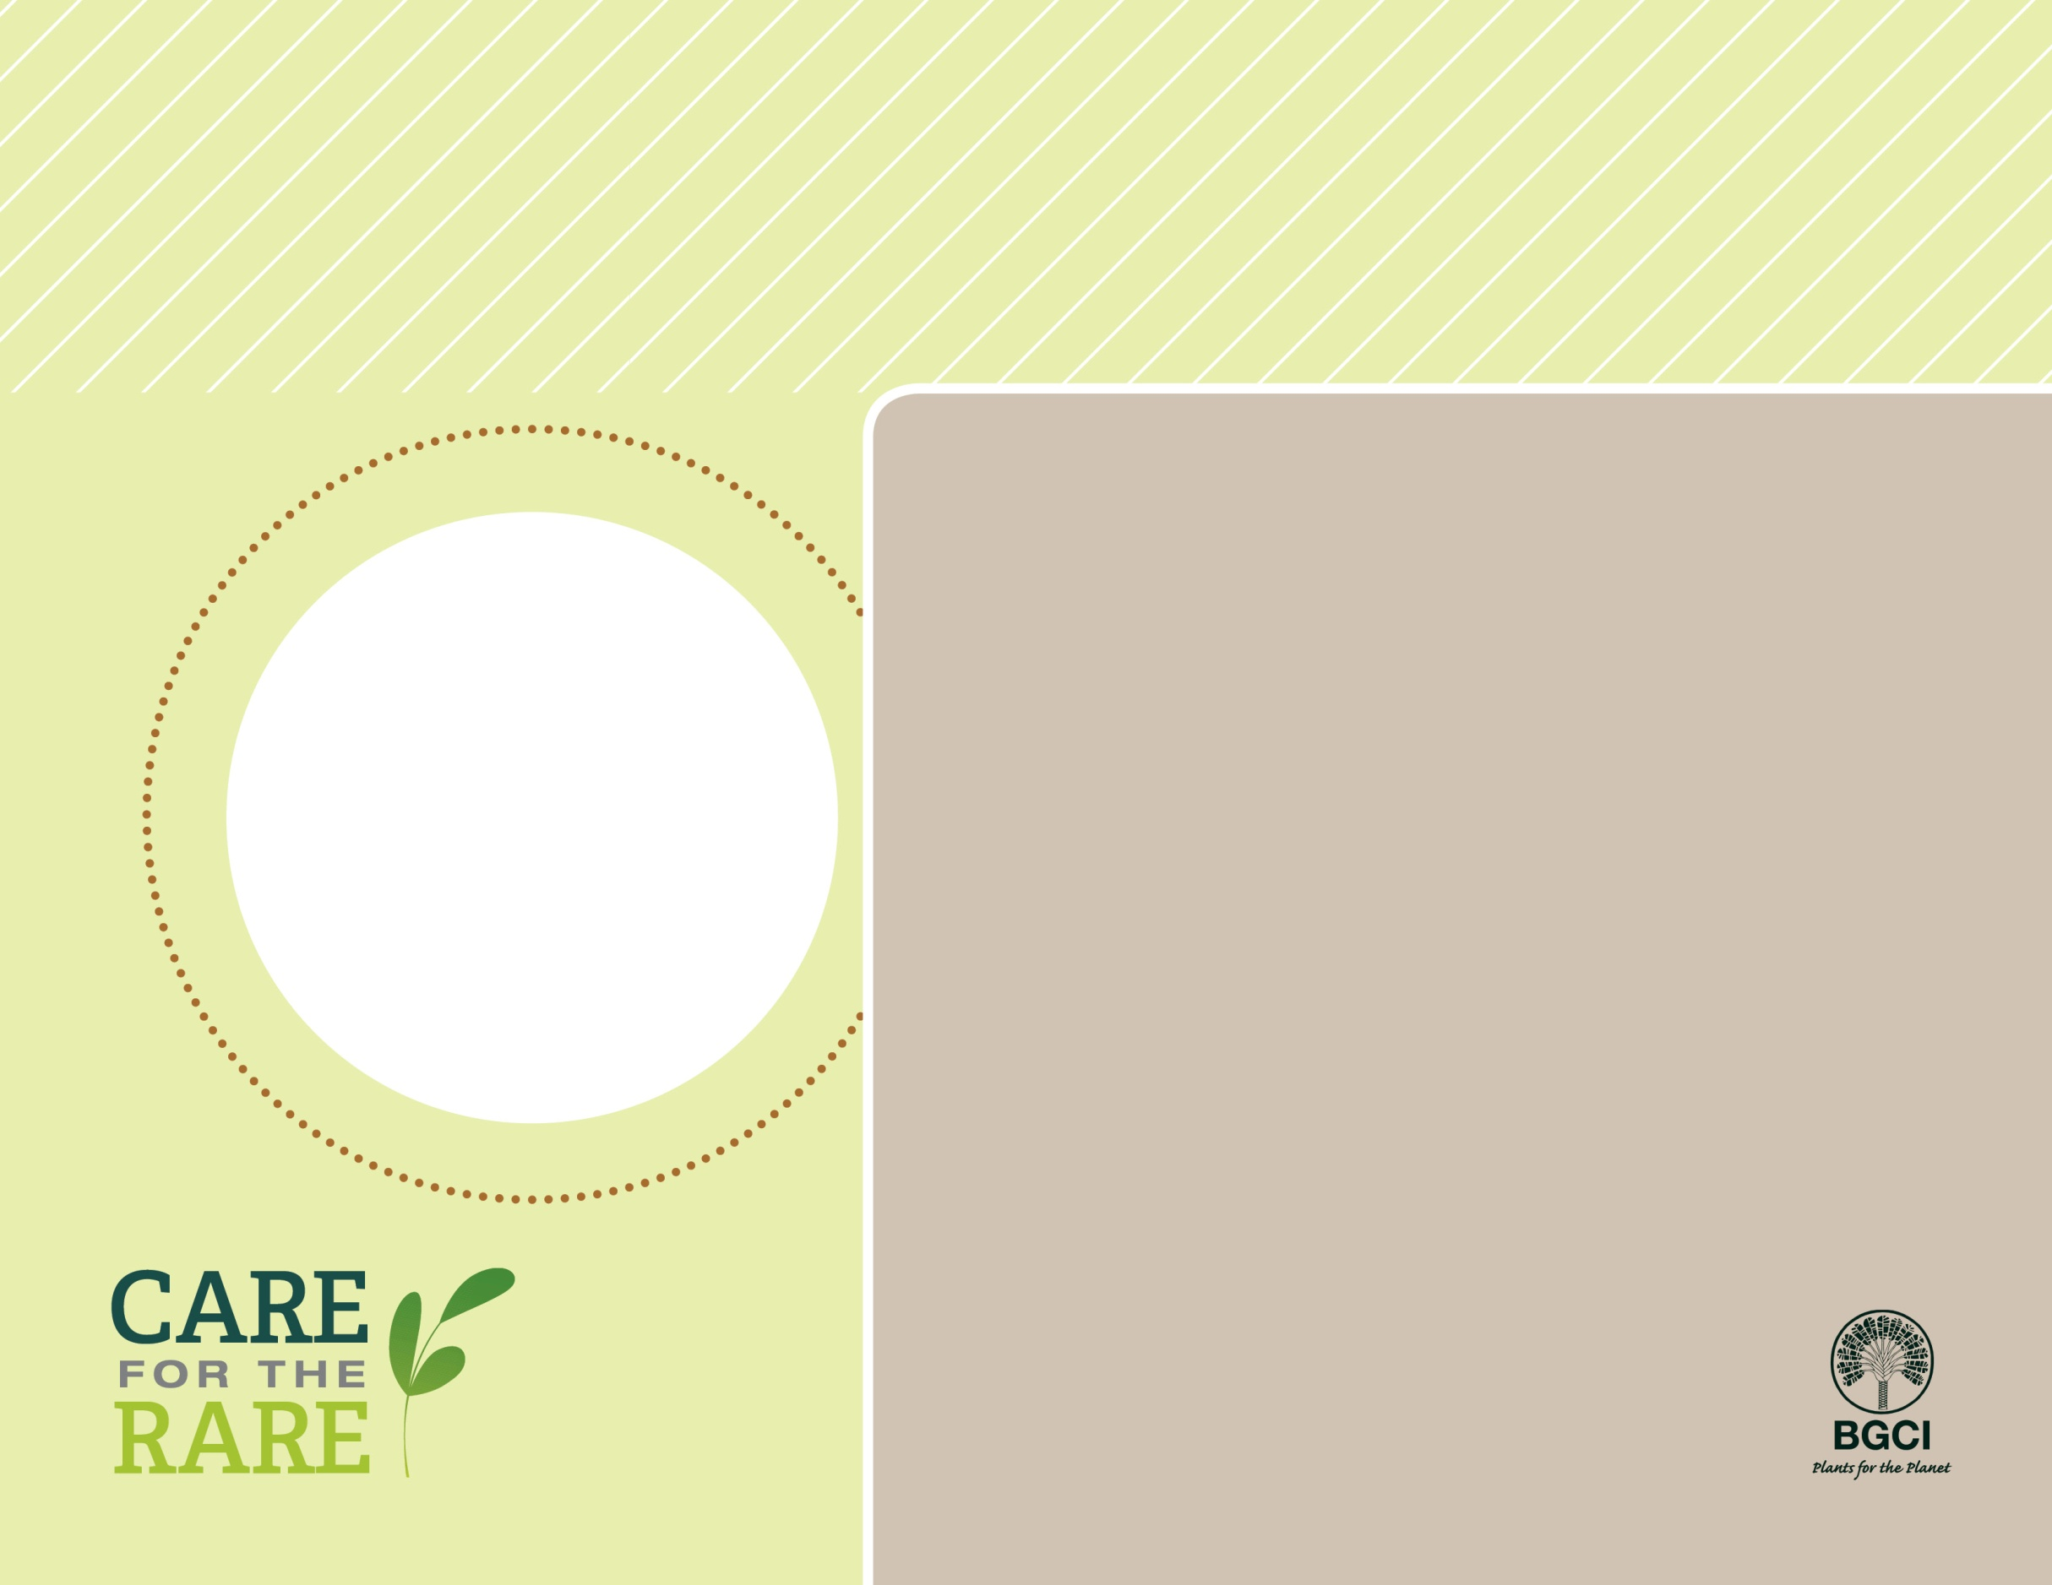

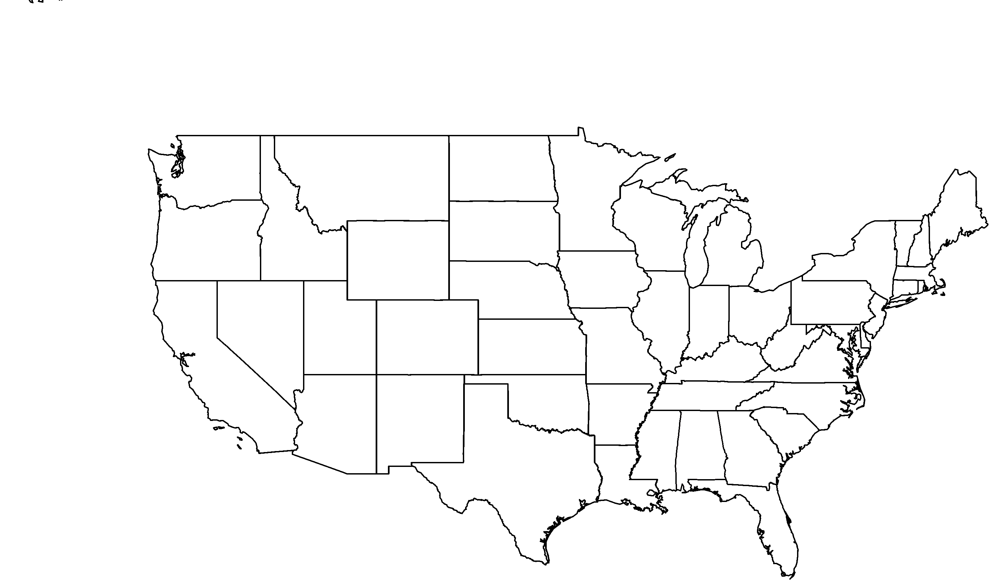

**About me:** I call the Appalachian Mountains of Alabama my only home. I have really beautiful flowers that provide nectar to butterflies and bees in May and June

**Why I’m rare:** My habitat is being converted to pine plantations for logging, and invasive plants are competing with me for space, light , and water. It is difficult to survive in these new conditions.

**My story:** You can find me growing at six botanic gardens. These gardens are learning things about me (like how to germinate my seeds) that will help keep me from becoming extinct.

**How you can help:** Make sure plants you buy for your garden are not invasive, and replace invasive plants in your garden with native alternatives.

Alabama phlox(*Phlox pulchra*)

PHOTO BY: ALAN CRESSLER