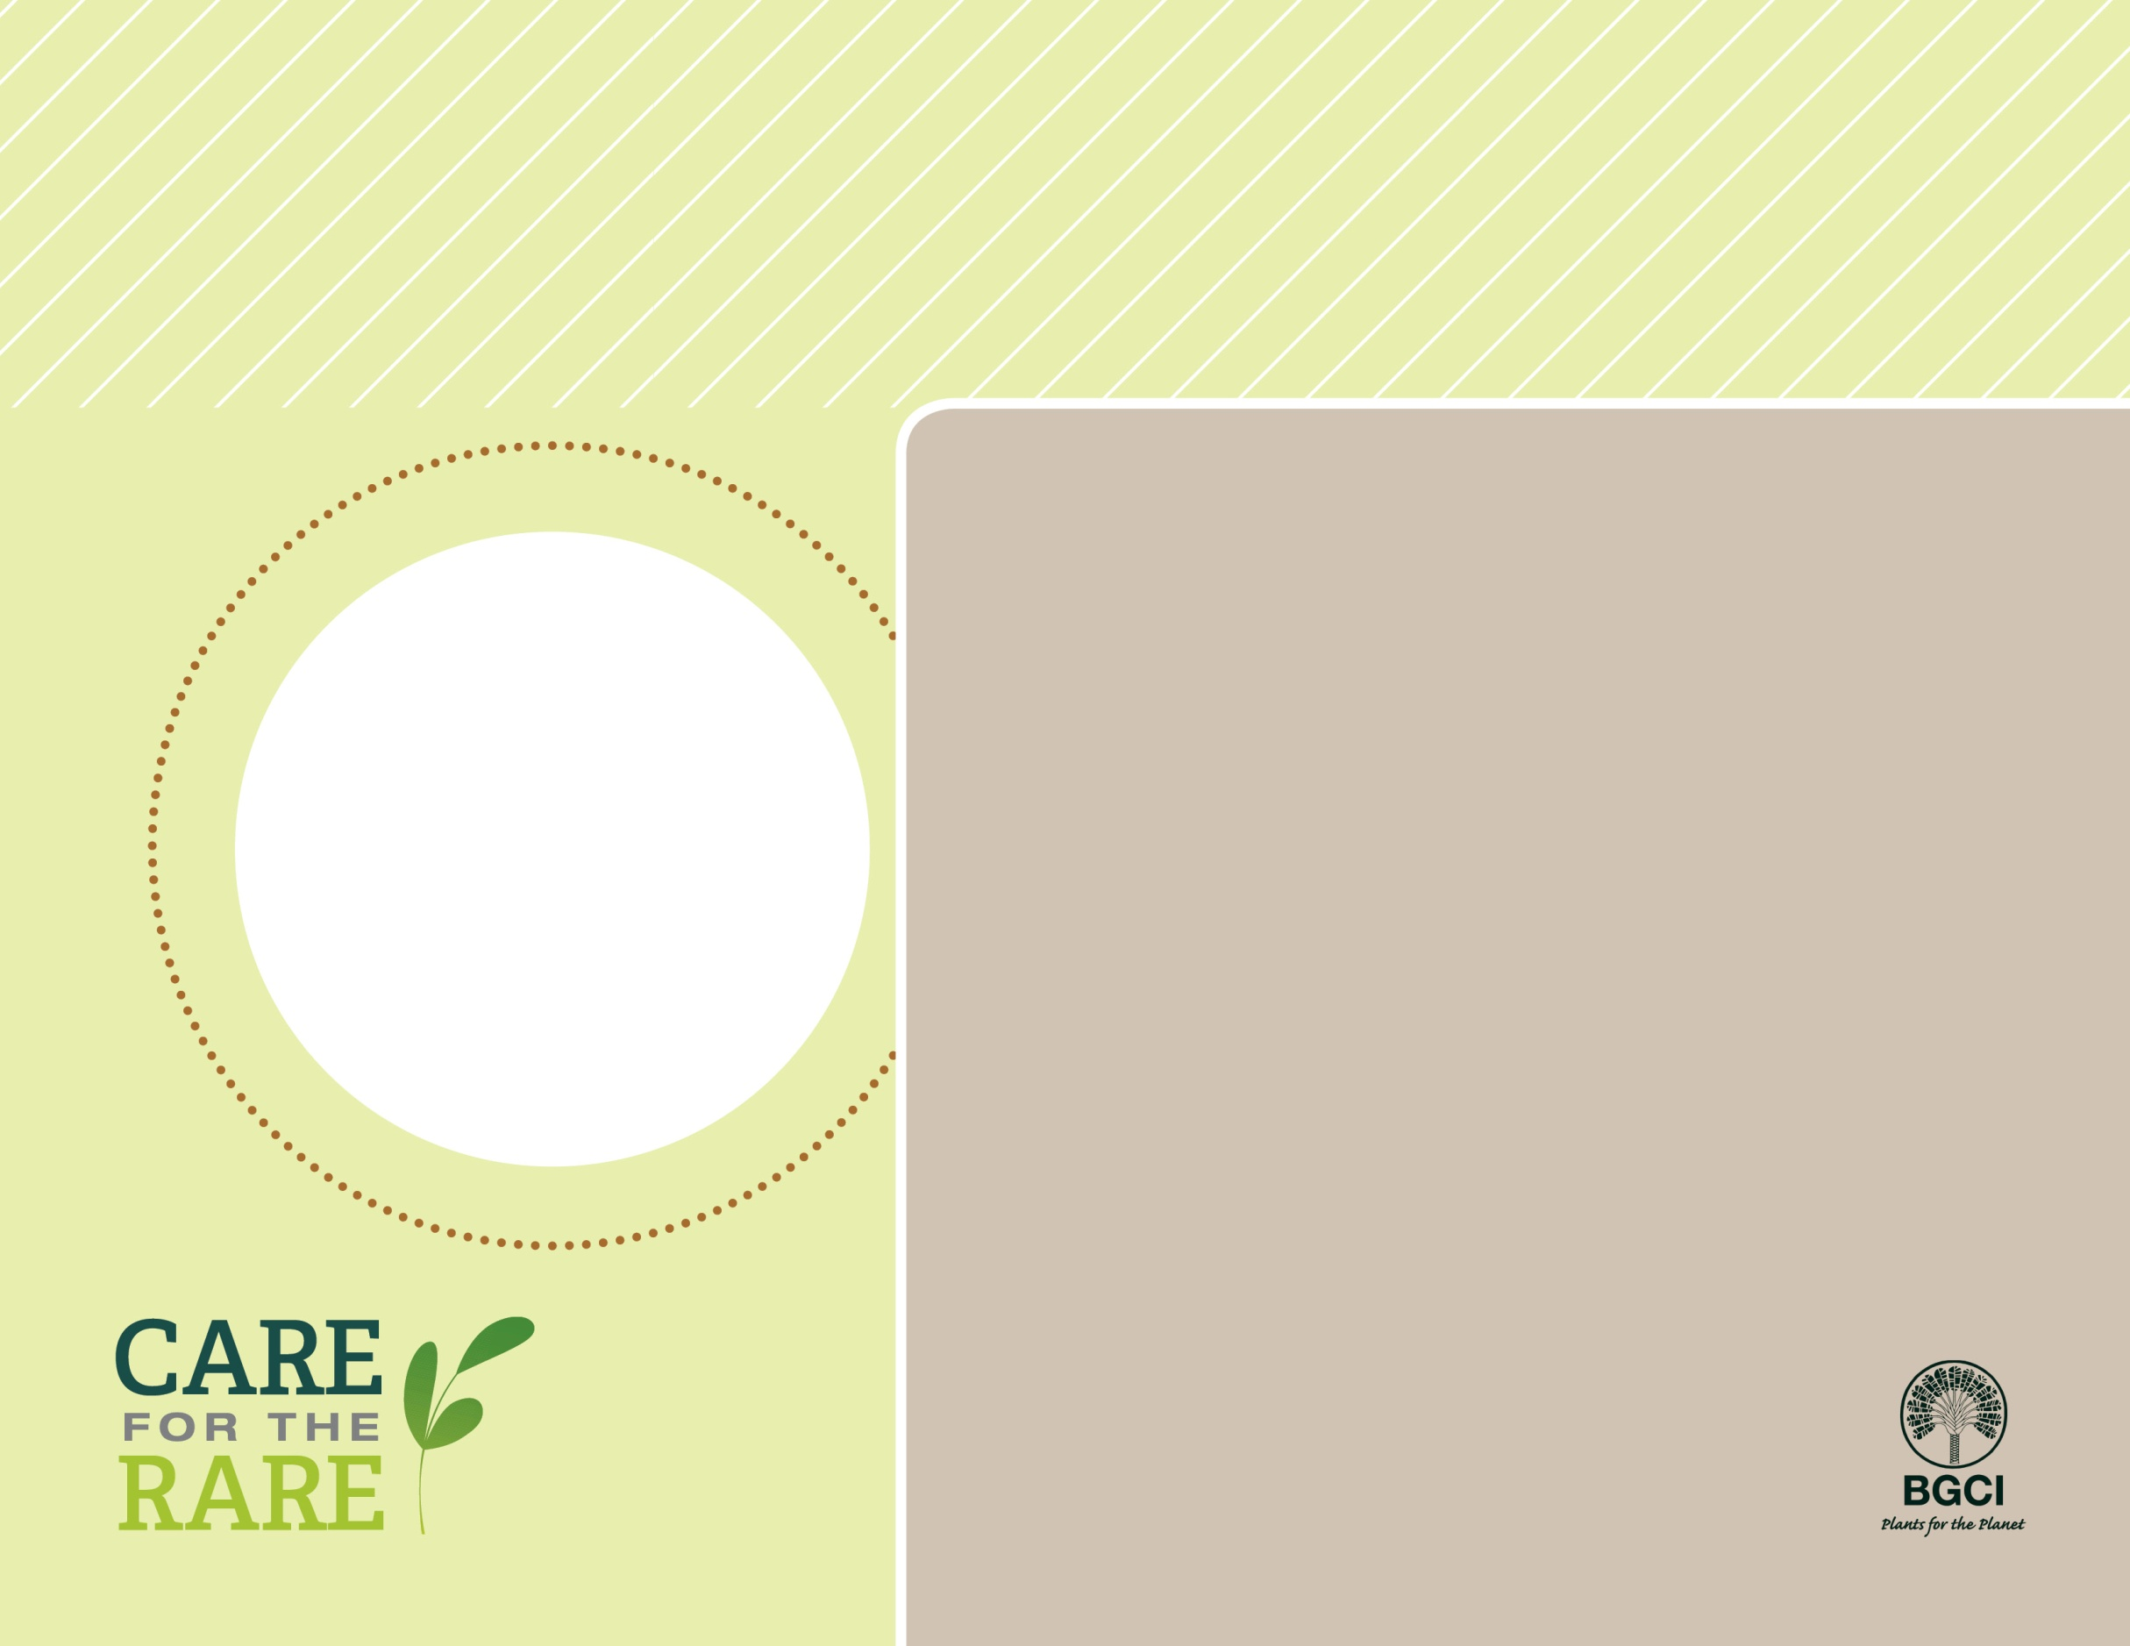

**About me:** I am the rarest pine in all of North America. My mainland population, in and near the Torrey Pines State Reserve, is confined to the low coastal bluffs flanking the Soledad Valley in San Diego County, California. My other population exists on Santa Rosa Island off the coast of southern California,

**Why I’m rare:** I am under attack from five-spined engraver beetles (*Ips paraconfusus*) who lay their eggs under my bark. When the larvae hatch they love to eat my inner bark and other parts that are essential for me to continue to grow.

**My story:** I am the only pine tree you will see in the Torrey Pines State Reserve. I tend to grow larger in the Garden than the wild. My branches hold large woody cones (4 to 6 inches) with thick scales ending in a thick, straight spine.

**How you can help:** Volunteer to help restore my natural home and prevent these aggressive beetles from munching on my inner bark.

Torrey Pine

*Pinus torreyana subsp. torreyana*

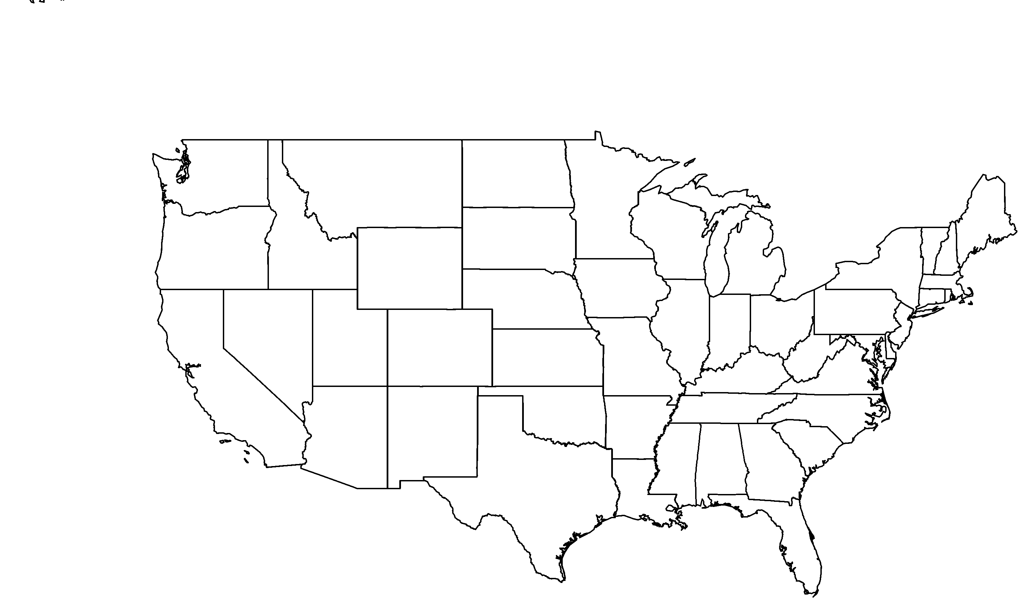

**PHOTO BY: SANTA ANA BOTANIC GARDEN**

**Your**

**Logo**

**Here**