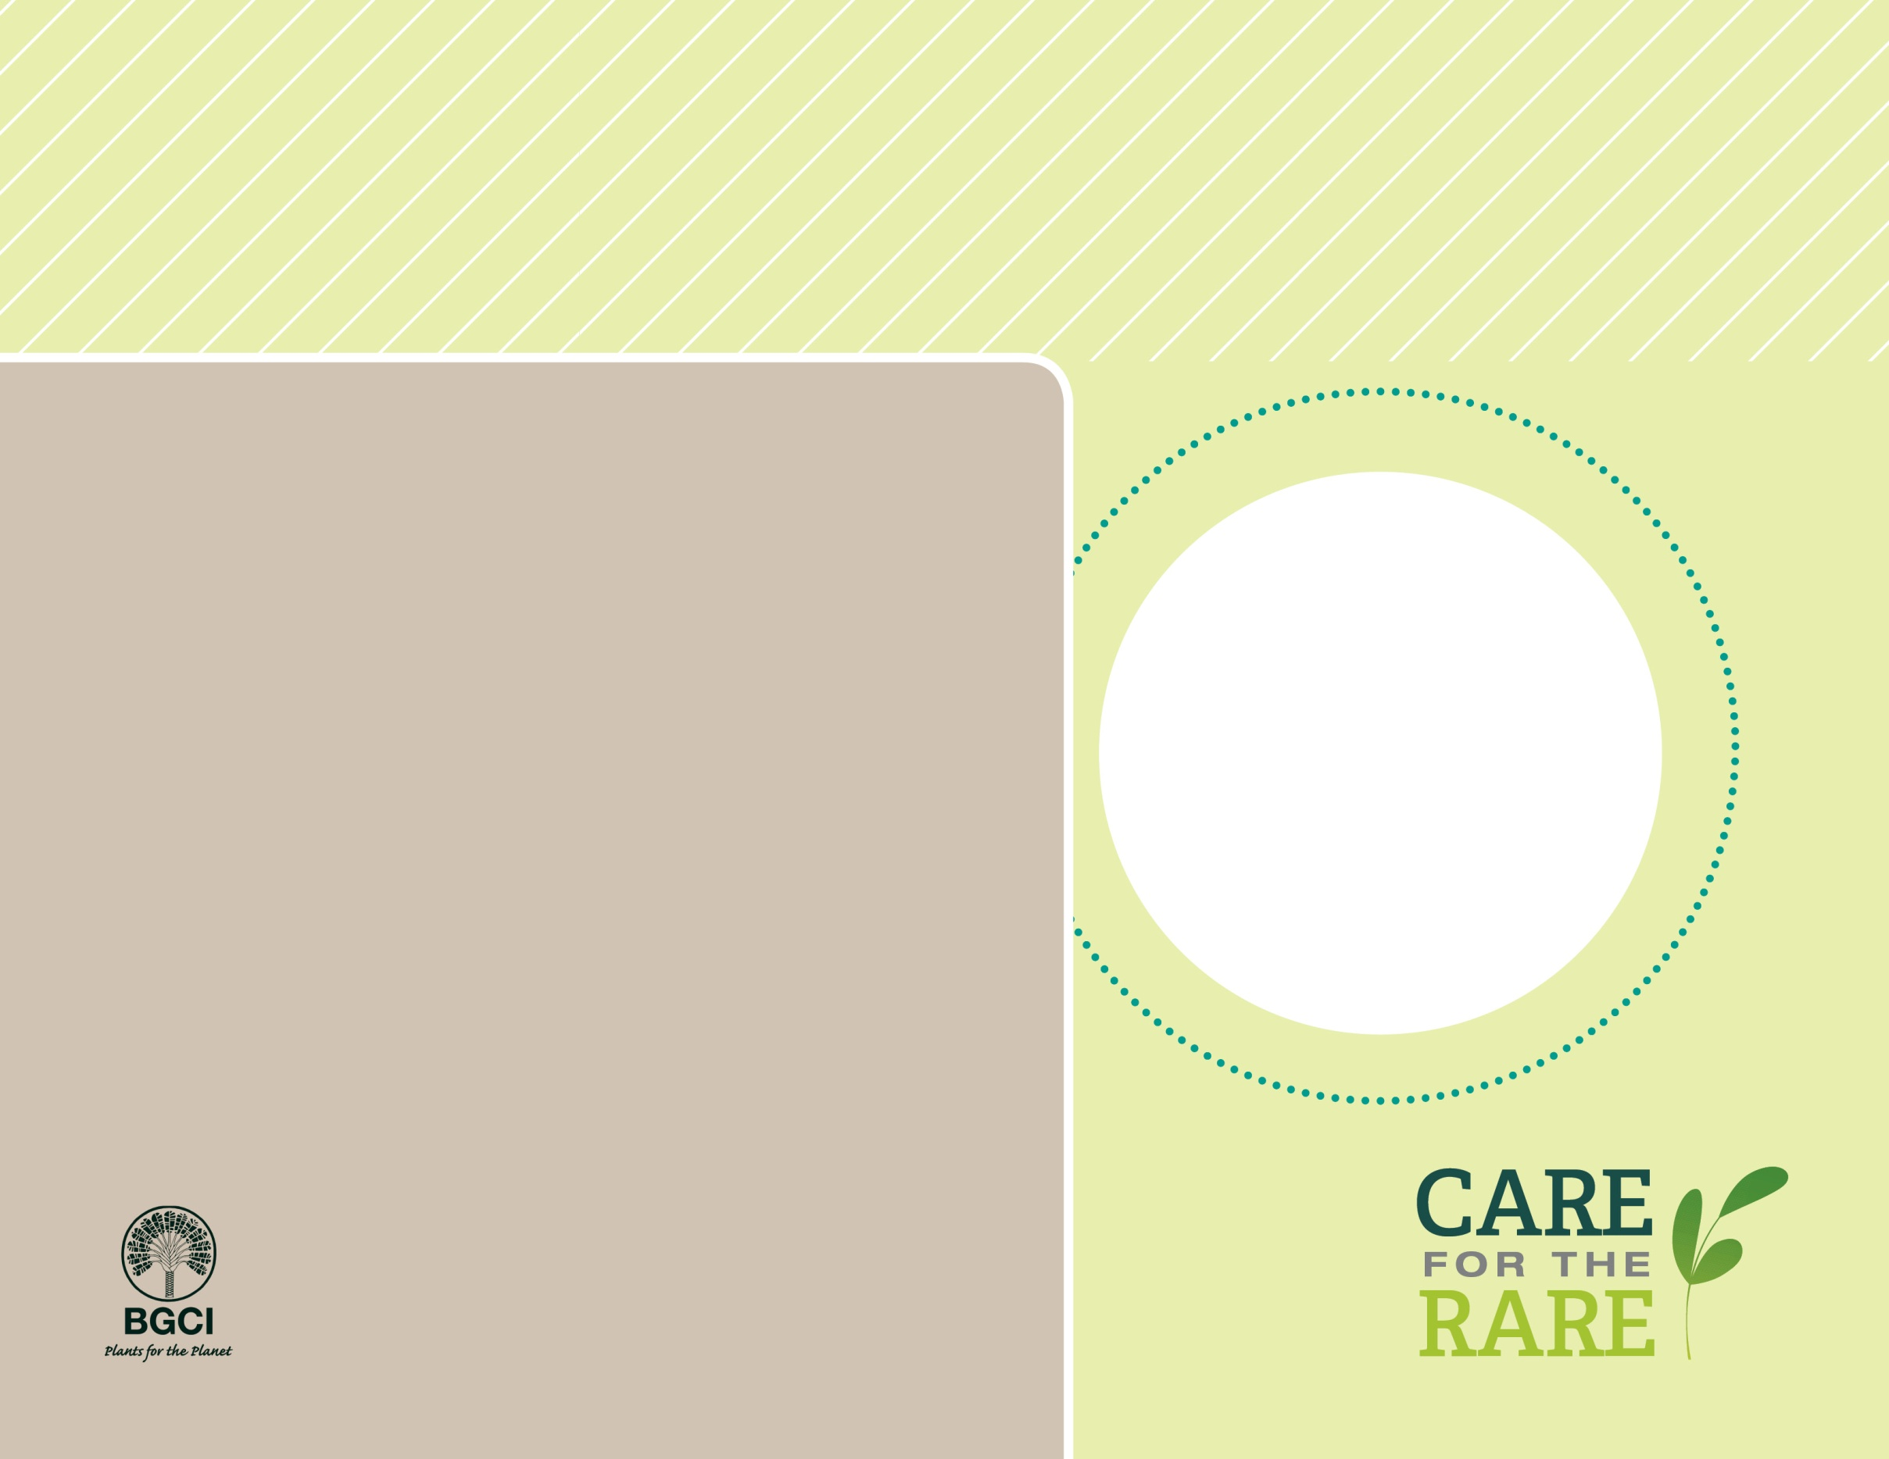

**About me:** People didn’t know about me until 1978, when I was discovered in a very small area in northeastern Australia. Today, I am one of the most popular landscape palms in the world due to my interesting fox tail leaves and my nice mature height of 30 feet.

**Why I’m rare:** After my discovery, I was illegally collected in the wild to sell to gardeners, which almost caused my extinction!

**My story:** Today, my entire native population is protected inside the Cape Melville National Park in Australia. Australian law prevents harvesting me from the wild, although I live in a very small area, which is a threat to my long-term survival.

**How you can help:** Make sure all plants you buy are responsibly grown and not collected from the wild.

Foxtail palm*Wodyetia bifurcata*

**PHOTO BY: Peter Richards (ARKive)**

**Your**

**Logo**

**Here**